IDEATION PHASE – DOCUMENT 3:

EMPATHY MAP CANVAS
Date | 06 November 2025
Team ID | NM2025TMID08097
Project Name | To supply Leftover Food to Poor
Maximum Marks | 4 Marks

Title: Empathy Mapping for “FoodConnect – To Supply Leftover Food to Poor”

1. Objective
The goal of this empathy mapping phase is to understand the emotions, motivations, and challenges of every stakeholder involved in the FoodConnect system — including donors, volunteers, NGOs, and recipients (beneficiaries).
By mapping what each user Says, Thinks, Does, and Feels, we can design a more human-centered Salesforce application that truly meets user needs rather than just providing a technical fix.

2. Stakeholders Identified
The empathy map focuses on four key user personas in the FoodConnect ecosystem:
Persona | Role | Goal | Pain Points
Donor (Restaurant/Event Organizer) | Provides surplus food | Reduce waste responsibly | No structured donation system
Volunteer | Collects and delivers food | Help the needy efficiently | Lack of coordination and unclear routes
NGO Administrator | Oversees donation operations | Ensure food reaches right people | Manual tracking and delays
Recipient (Needy Person) | Receives food | Access fresh food regularly | Irregular availability and quality issues

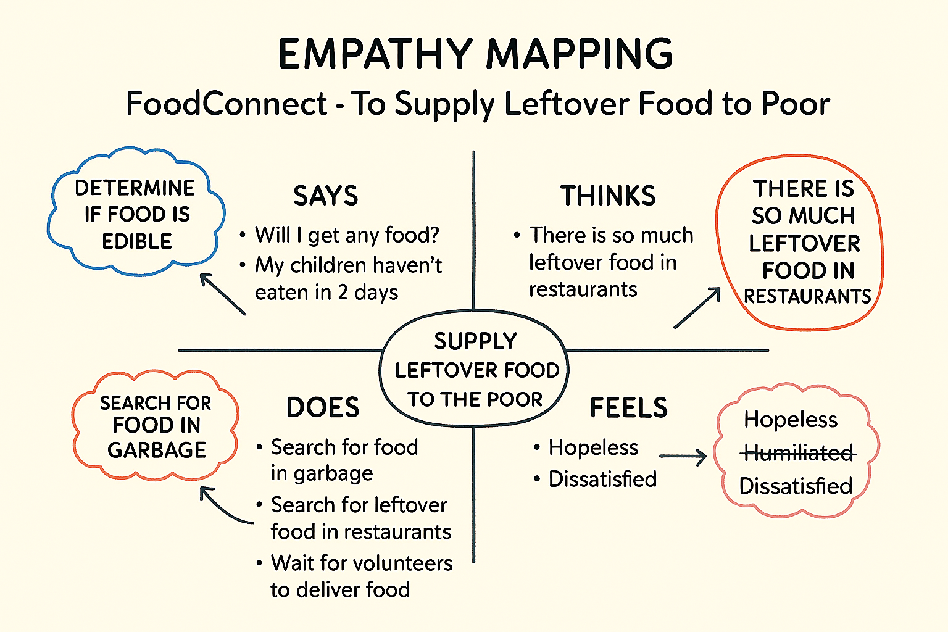

3. Empathy Map Canvas Layout
Below is the empathy mapping framework applied to all four personas.
Quadrant | Description | Key Insights
SAYS | What users express verbally during interaction or interviews | “We want a faster, trusted way to distribute food.”
THINKS | What users think internally but may not openly share | “I hope the food really reaches those in need.”
DOES | Actions or behaviors the users perform | Calls NGOs, delivers food manually, tracks deliveries via phone
FEELS | Emotional state, frustrations, and aspirations | Donors feel guilt over waste; Volunteers feel proud but under-supported

4. Empathy Map Analysis
By mapping these insights, several crucial observations were made:
- Emotional Connection:
Volunteers and donors share a deep emotional connection to the cause but are often frustrated due to inefficient coordination.
- Cognitive Dissonance:
Donors think they are doing good, but they feel dissatisfied when food does not reach the right people — this indicates a need for transparency and tracking.
- Behavioral Pattern:
Volunteers are motivated but need structured guidance — like routes, timing, and clear delivery assignments.
- NGO Pain Point:
Administrators struggle with record-keeping and impact measurement, which can easily be solved through Salesforce Dashboards and Reports.

5. Insights Derived
From the empathy mapping exercise, five actionable insights were derived:
- Automation reduces emotional fatigue.
Users want systems that handle repetitive coordination tasks automatically.
- Trust is built through visibility.
Both donors and recipients want transparent information about where food goes.
- Ease of use determines adoption.
The simpler the app, the faster NGOs and volunteers will embrace it.
- Gamification motivates volunteers.
Recognition through badges or ratings boosts volunteer participation.
- Data equals credibility.
Dashboards showing “Meals Served” and “Deliveries Completed” enhance NGO trustworthiness.

6. Design Implications for FoodConnect
The empathy mapping results directly influenced design decisions in the Salesforce app:
Insight | Design Decision
Lack of coordination | Introduced Task Assignment Object with notifications
Need for transparency | Created Dashboards for tracking all operations
Emotional connection | Added Feedback Field for volunteers and NGOs
Simplicity requirement | Designed a minimal Lightning App with 5 core tabs
Recognition need | Added Rating Field and Volunteer Leaderboard

7. Empathy Map Canvas Summary
The empathy map revealed that the key to success lies not just in building automation, but in designing with empathy.
Salesforce tools such as Flow Builder, Reports, and Experience Cloud allow FoodConnect to:
- Capture human emotion in data-driven insights.
- Build trust through visible metrics.
- Deliver both social and emotional satisfaction.
In short, empathy mapping transformed FoodConnect from a technical project into a socially impactful solution.

